NNA Directors offer quotes for World Press Freedom Day
NNA Chair John Galer, publisher of The Journal-News in Hillsboro, Illinois, said, “Freedom of the press is a core principle of this country. Embodied in the First Amendment, it allows the press to act as a watchdog over government affairs, in keeping citizens informed. Walter Cronkite said it best though: ‘Freedom of the press is not just important to democracy; it is democracy.’”
NNA Past President (2013) Robert M. Williams Jr., NNA director of creative resources, said, “For me, freedom of the press is both a privilege and an obligation. It’s a privilege that my readers count on, knowing I will stand up, often in their stead, as their representative before the seat of government to keep them aware and informed. After they know I accept their privilege, it then becomes my obligation not to let them down. My readers depend on me!”
NNA Past President (2019-2020) Matt Adelman, publisher, Douglas (Wyoming) Budget, said, “In this time when press freedoms are under attack and free speech rights are being trampled by those in power and by those who only want their version of reality expressed, it is incumbent upon all of us to protect the First Amendment’s guarantees of free speech, free press and the right to assemble. While that battle is never ending, having a day to recognize the vital importance a free press brings to a democracy is critical to making the public understand a loss of one right will lead to a loss of all, thus resulting in the demise of democracy and the rise of authoritarian figures — whether that be on a national stage, in a single state or university or even just in one’s own community. A free press ensures our experiment in representative democracy continues for another 250 years.”
NNA Past President (2015) Chip Hutcheson, retired publisher, The Times Leader in Princeton, Kentucky, said, “A free press is one of the bedrocks of our nation. Our Founding Fathers recognized that and made sure to enshrine it in this nation's core principles. On this day, let us celebrate the role that a free press has paid in our nation's history.”
NNA Past President (2000-2001) Diane Everson, publisher, The Edgerton (Wisconsin) Reporter, said, “Freedom of the press isn’t just about reporting from war zones or capitals — it’s also about telling the truth in small towns, holding local power accountable, and keeping neighbors informed. That’s what we do every week.”
NNA Director Kate Oliver, general manager of the Rappahannock Record in Kilmarnock, Virginia, shared from Rappahannock Record Editor Robert Mason. “In one word: Opportunity — Freedom of the press enables us to pursue life, liberty and happiness and to openly share all that we find with others; to question authority; to explore all possibilities; to be creative; to absorb knowledge.”

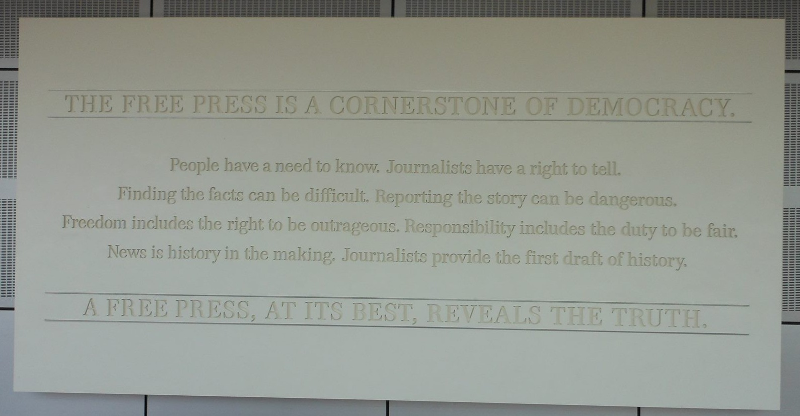
Photo by Mary Galer Herschelman, The Journal-News, Hillsboro, Illinois
This is a photo from the now-closed Newseum in Washington, D.C. “I’m not sure I could say it any better than they did,” Mary Galer Herschelman, The Journal-News, Hillsboro, Illinois, wrote, “but we keep it as our [Facebook] cover photo to remind our readers how critical Freedom of the Press is. People have a need to know. Journalists have a right to tell. Finding the facts can be difficult. Reporting the story can be dangerous. Responsibility includes the duty to be fair. News is history in the making. Journalists provide the first draft of history. A free press, at its best, reveals the truth.”

